**Spring**

16

Human Resources: Aaron Jessie, Carson Hartig, Emily Pawsat, Sara Attarzadeh

Dave and Buster’s

Human Resources Business Proposal

April 18, 2016

08

**Fall**

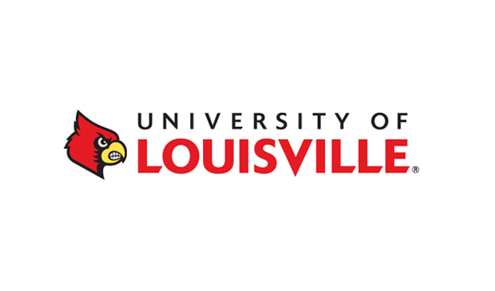Human Resources   
University of Louisville  
2301 South Third Street   
Louisville KY, 40292

Metro Council

601 W. Jefferson Street

Louisville KY, 40202

February 2, 2016

Dear Metro Council,

We are contacting you in regards to a class project we have been involved with this semester in our Business Communications course at the University of Louisville. As a class, we have been responsible for finding a business to bring to Louisville that would help fill some of the holes in the current market. After considerable research, we decided that Dave and Busters would be a perfect fit for our city.

Our specific group was responsible for looking at the human resources needs of Dave and Buster’s. We began by analyzing the current market, researching Dave and Buster’s current employment strategies, and developing a clear understanding of Louisville’s employment policies/wage structures. This in turn led us to form a recruitment, training, and retention strategy, which will be shared in detail with you throughout the remainder of this document.

Dave and Buster’s will generate considerable employment opportunities for Louisville while giving its residents the perfect place for dinning, gaming, and hosting events. The next closest location is over 115 miles away. This creates the perfect opportunity for Louisville to be the first city in Kentucky to bring this entertainment sensation to the state.

We hope that you see the same potential in this business as we do and would greatly appreciate your support as we continue to push this idea into a reality. Please let us know if you have any questions regarding our research or in general regarding this opportunity to improve our local economy.

Sincerely,

Emily Pawsat, Aaron Jessie, Sara Attarzadeh, Carson Hartig

**Table of Contents**

1. Executive Summary 4
2. Introduction 5
3. Recruitment 6
   1. Target Employees 6
   2. Present Workforce in Louisville 6
   3. Recruitment Strategy 8
4. Training 11
   1. Job Descriptions 11
   2. Policies and Procedures 12
   3. Training Program 14
   4. Training Budget 15
5. Retention 16
   1. Expectations 16
   2. Employee Pay 16
   3. Tracking Responsibilities 17
   4. Employee Benefits 17
   5. Retention Budget 18
6. Final Budget 19
7. Conclusion 20
8. Works Cited 21
9. Appendix 23

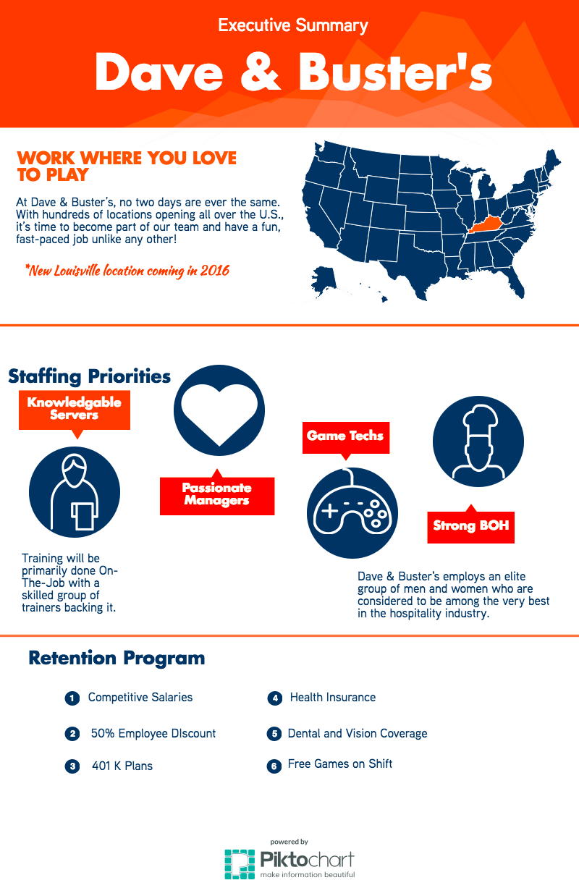

**Introduction**

A successful introduction of a business to a new city requires harmony between the labor force present and the goals of the company. When considering how Dave and Buster’s would fit into the Louisville market, it appears this harmony exists. As it stands, this mutually beneficial opportunity could produce numerous jobs for the citizens of Louisville, especially the younger population. To demonstrate the feasibility of adding a Dave and Buster's to the city, it is important to outline how the company will recruit, train, and retain employees of all types. A discussion of the budget to carry out such a strategy is necessary, as well. The Human Resources (HR) team has worked intensely in creating a top-notch recruitment strategy, training method, and retention plan.

First, this business proposal will touch on recruitment. This section will pinpoint the target employee types for Dave and Buster’s positions. Those targets will then be compared to the available workforce in Louisville. The recruitment section will end with a strategy for attracting employees, and the budget necessary to do so. The information from this section was gathered from a number of sources, including the National Restaurant Association, the Houston Chronicle, Chipotle, and various online recruitment guides.

Second, the training method will be laid out. A standard practice for educating employees on their rights and responsibilities at Dave & Buster's must be detailed well ahead of opening day. This section will first outline the hierarchy of roles, from salaried to hourly positions. It will also provide thorough agendas for the training program. To end, the Dave & Buster's policies will be reviewed, defining expectations from both D&B, as well as federal/state law. Much of the training section drew from training plans devised by similar restaurants, such as Texas Roadhouse, as well as D&B’s own website.

Third, a plan to retain employees once hired will be discussed. Turnover can be very costly for a company. To combat the issue, expectations of each worker will be explained. Then, the competitive salaries to be offered will be presented. Next, a method for tracking employee responsibility fulfillment will be outlined. Finally, possible employee benefits will be suggested. Sources of retention information included the D&B website, Glassdoor, and restaurant magazines.

**Recruitment**

Across the nation, people have come to expect a certain excellence out of their Dave and Buster’s experience. To remain a leader in the restaurant and entertainment industries, Dave and Buster’s must be dedicated to attracting the best employees to care for its customers. The recruitment considerations and strategies outlined in this section are designed to help Dave and Buster’s arrive in Louisville on top, and ensure that the city and the restaurant are able to unite together in a mutually advantageous relationship.

**Section 1: Target Employees**

Dave and Buster's is aware that it must employ an “elite group of men and women who are considered to be among the very best in the hospitality industry” (“Dave & Buster’s Careers”). The question is, what makes someone the best? There are many qualities industry professionals look for in their potential employees. Though sometimes subjective to the individual, there are several characteristics the overwhelming majority of restaurant professionals agree are crucial for employee success. The Houston Chronicle identified four such qualities and skills: friendly personality, ability to multitask, accuracy, and flexibility (Carabelli).

Without any one of these characteristics, the quality of service provided by an employee can be diminished significantly. First, a friendly personality is necessary to create a light atmosphere, allowing customers to relax and enjoy themselves. An employee must be able to remain composed at all times. Second, employees in the restaurant business oftentimes have to complete many activities at once. Therefore, they need to be able to balance their time. Third, accuracy in delivery is always crucial. A mistake can often be costly to the restaurant, and time consuming to correct. Finally, restaurant schedules are constantly changing. A suitable employee needs to be able to work around these changes to accommodate the needs of the business (Carabelli).

Along with these four characteristics, the Houston Chronicle provided an additional list of qualities that are desirable in managers. It includes patience, high energy, strong interpersonal skills, and fast thinking (Kokemuller). Potential managers should possess both sets of characteristics to work successfully and lead others.

Finally, aside from salaried workers, there is typically no educational experience required to work in the service industry. As long as the individual has the proper skills, their educational background is not a concern to the business. Likewise, as long as the individual is above the minimum legal age to work, and capable of performing the tasks required of them, they can be of any age.

**Section 2: Present Workforce in Louisville**

It appears that the available labor force in Louisville fits well with statistics drawn from restaurants in the US. According to the National Restaurant Association, Millennial’s have been dominating the restaurant workforce for the past decade. The next largest workforce group includes teenagers between the ages of 16 and 19 (“Restaurant Workforce Demographics”).

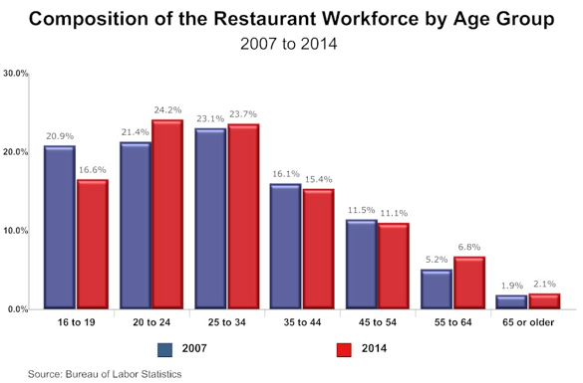

         Figure source: National Restaurant Association

Given these statistics, Dave and Buster’s should expect to find a greater pool of potential workers in areas with large young adult populations. Luckily, Louisville is a hub for Millennials in the state of Kentucky. With four major colleges, and several other higher education institutions, the Louisville Metropolitan area saw the enrollment of roughly 70,000 students in 2014 (“Economic Development"). Cities that have similar student populations include Richmond, VA and Austin, TX, both of which already have Dave and Buster’s locations (“Highest College”). This means that it will likely be no challenge for the restaurant to find individuals willing to work here in Louisville.

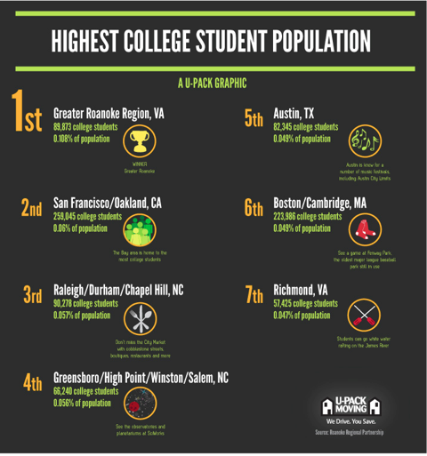

                          Figure Source: U-Pack

**Section 3: Louisville D&B Recruitment Strategy**

While Dave & Buster's is certainly a unique company, combining the best of food and entertainment, many potential employees may look at it in a similar light as they would typical eateries when deciding where to apply. That is what makes a good recruitment strategy so critical, especially in the restaurant industry. A company needs to differentiate to appear attractive. A plan such as the one outlined in this section can do just that for Dave and Buster’s. This plan draws from successful recruitment actions taken by various companies such as Chipotle.

* **Utilize Social Media**: Given that a large proportion of the restaurant workforce is made up of Millennials, using social media to spread the word about D&B careers is a given. All major social media sites should be utilized to let Louisville users know about open positions. These major social media sites include Facebook, Twitter, and LinkedIn.

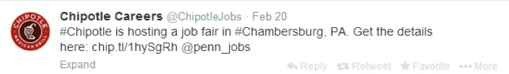

Figure source: @ChipotleTweets

* **Publicize Social Responsibility**: Today, employees don’t simply want to work at a business that pays well. Many people want to know that their company takes part in socially and environmentally responsible activities. Dave and Buster’s donates significant funds to the Make-A-Wish foundation, a charity that grants the wishes of children who suffer from terminal illnesses. This is certainly something they should emphasize to potential employees (“DAVE & BUSTER’S IS A PROUD SPONSOR”).



Figure Source: @ChipotleTweets

* **Blogging**: A blog may be used to create a more personal atmosphere. An example of this would be Chipotle’s use of “real stories,” in which employees discuss their experiences working for the restaurant and how they were able to move up in the company (Shoemake).
* **Post Job Ads**: This is a tactic that will be used specifically for salaried positions. Positing an ad on sites like Simply Hired is quick and easy. However, it does cost money to create ads. Dave & Buster's should take care in how they write their job ads to appeal to their target receiver. RecruitLoop provides a guide to writing compelling job ads, and includes suggestions such as “offer challenges, not rewards” and to “keep it simple and true” (“9 Simple Steps”).
* **Budget:** One budget expenditure is necessary to get the recruitment strategy going. The budget will be listed on a per-year basis.

|  |  |
| --- | --- |
| **Purpose** | **Expenditure Amount** |
| Simply Hired Ads (three ads) | $300 |
| **Total** | $300 |

Source: Simply Hired

* **Word of Mouth**: Sometimes, the best way to recruit is through the people that already surround the company. This may be especially useful with server and hostess positions.

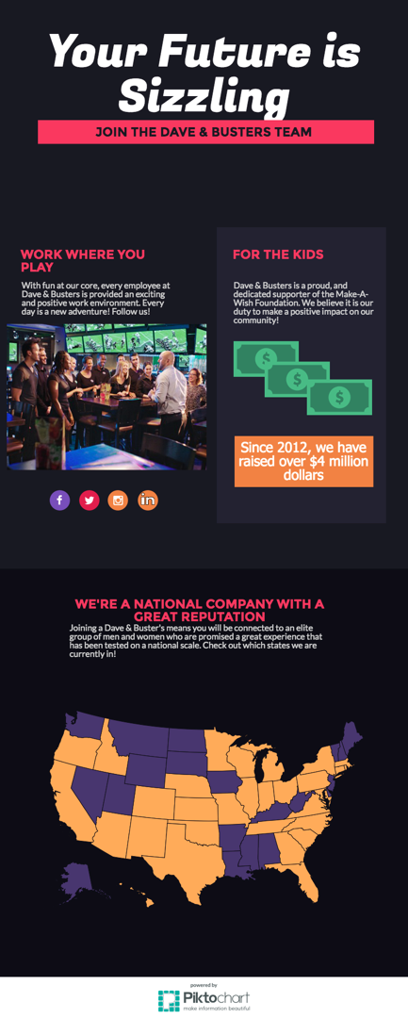

         Figure Source: Dave and Busters

**Training**

Dave and Buster’s stresses the importance of proper training in order to ensure that their employees understand their job responsibilities and have the skills required to create the best dining experience possible for their guests. Our training program is modeled after the similar, successful restaurant Texas Roadhouse (see Appendix A).

**Section 1: Job Descriptions**

Salary Managers:

General Manager - responsible for all administrative functions of the business which includes leading and directing employees, delegating administrative tasks such as accounting, paperwork or payroll, and handling disputes or any other issues.

Service Manager - responsible for the overall operations of the front of the house which includes running the host stand, discounting checks, counting drawers for retail and the bartenders. Service managers also handle guest relations throughout the night and make sure the shift is running smoothly.

Kitchen Manager - responsible for overall operations of the back of the house which includes hiring staff, training on food preparation and safety, and purchasing food and stock.

Hourly Employees - Front of House:

Server - servers are expected to follow food safety and sanitation practices, have high energy, suggest specific food/drink items through use of salesmanship, use the computer system effectively, exhibit teamwork, and provide excellent service to guests.

Busser - bussers are expected to assist guest in whatever they need, assist servers in whatever they need, clear and clean tables in 30-45 seconds, keep service area cleaned and stocked, and run food.

Host/hostesses - hosts are expected to seat and greet the guests, take guest information for parties and reservations, take and place to-go orders, coordinate seat chart, and open doors for guests when they arrive and leave.

Senior games Technician- senior game technicians handle activating and reloading game cards for guests and distributing prizes for tickets.

Bartender - bartenders are expected to follow standard beverage presentation guidelines, take orders and prepare alcoholic beverages, serve responsibly, use salesmanship, follow liquor laws, and maintain good sanitation.

Hourly Employees - Back of House:

Point- point is the leader of the line to send food out. Responsibilities include assembling food orders and placing the appropriate side items with the orders.

Broil- broilers are in charge of seasoning, grilling, and searing meat to the correct temperatures. They are also expected to follow proper food safety when handling meat. This includes recognizing the signs of bad meat.

Fry- fry is in charge of preparing multiple appetizers and fried side items in a timely manner and sending them out with the appropriate garnishes and sauces.

Expo- responsible for ensuring that each guest receives the correct food in a timely manner by working side by side with the kitchen as well as servers.

Dishwasher - dishwashers are expected to operate the dish machine, supervise proper rinse and wash temperatures, change water every two hours, storing and using dish chemicals properly, setting up and organizing the dish racks and window, and removing trash.

**Section 2: Policies and Procedures**

Drawing from the Texas Roadhouse Manual (see Appendix A) and our investigation of the Dave and Buster’s website (https://www.daveandBuster's.com), the following policies and procedures have been established.

Dress - There are different dress expectations depending on the employee’s job role.

* Managers- managers are required to wear a Dave and Buster’s polo, solid black or brown belt, and fitted khakis.
* Kitchen staff - kitchen staff is required to wear non-slip closed toe shoes, Dave and Buster’s t shirts, fitted blue jeans, solid black or brown belt, and a hair net.
* Everyone else - everyone else is required to wear non-slip closed toe shoes, Dave and Buster’s t-shirt, fitted blue jeans, solid black or brown belt, name tag, and an apron.

All visible piercings should be removed and tattoos should be covered up. Good hygiene and clean clothing is expected at all times. Unless you are a manager, you hair should be pulled back and off the face.

Harassment - Dave and Buster’s forbids any form of harassment or discrimination against applicants, employees, guests, or vendors because of a person’s race, gender, religion, age, disability, veteran status, sexual orientation, citizenship, national origin or any other legally protected status. All employees must take harassment and discrimination seriously.

What should an employee do if he/she sees or experiences harassing, discriminatory, or inappropriate behavior?

If an employee sees or experiences harassing, discriminatory, or inappropriate behavior it should be reported immediately. As with any violation of Dave and Buster’s policies, it should be reported whether or not the behavior was directed at that particular employee. No one, including a manager or supervisor, will be permitted to retaliate against the employee for reporting any type of discrimination, harassment, or misconduct, regardless of who the harasser or victim may be.

Here are ways an employee may raise a question or report a concern:

1. Call the Ethics Hotline: 1-877-273-9000. This is a toll free number and the information provided will be submitted in a written report. The employee may choose to remain anonymous if preferred.
2. Go the electronic Ethics Hotline by visiting the Dave and Buster’s website, [www.daveandBuster's.com/contact](https://www.daveandbusters.com/contact)
3. In person: an employee may talk, call, write, or email a manager about an issue that was experienced firsthand or witnessed occurring.

Open door policy- Dave and Buster’s has an open-door policy. All employees should feel free to discuss any questions, complaints, or concerns with their manager.

Work performance and behavior- Dave and Buster’s expects its employees to make a commitment to quality job performance. Poor performance or misconduct isn’t good for the employees or Dave and Buster’s and can result in termination. Poor performance or misconduct includes discrimination, harassment, disorderly conduct, insubordination, failure to wear proper uniform or identification, sleeping on the job, failure to obtain required certification or registration, improper cash-handling procedures, lying, using profanity, leaving work early, smoking or eating in prohibited areas, violation of safety or sanitation rules, or being discourteous or rude to a guest, employee, or vendor.

Payroll- Payments go out every other Friday for both exempt and nonexempt workers.

Alcohol and drug policy- Drinking on the job is prohibited. Being impaired or otherwise under the influence of alcohol on Dave and Buster’s property, regardless of whether or not the employee is in uniform, is also prohibited. If there is a company party with alcohol, those over the age of 21 are expected to drink responsibly. Any event where alcoholic beverages are served must be approved by the person with the most direct, senior-level supervisory responsibility. Unauthorized prescription drug use is prohibited and there is zero tolerance for possession, use, abuse, sale, transfer, distribution, or storage of illegal drugs or paraphernalia during working hours or while on company property.

Smoking, Tobacco Chewing and Gum Chewing- Smoking, tobacco chewing, and gum chewing are not permitted during an employee’s shift. An employee may only smoke with a manager’s approval during scheduled breaks and in a designated area.

Reporting an Illness - An employee must immediately tell his/her manager if he/she is sick and might be contagious. The employee should notify his/her manager and leave work immediately if one is experiencing the following: acute stomach distress, diarrhea, fever, sore throat, or vomiting.

Vacation- After one year of employment, an employee will be eligible to begin accruing and using vacation benefits if he/ she worked an average of 32 hours per week in the previous nine months of employment.

Personal Leave - Employees may request an unpaid personal leave of absence not to exceed thirty days. Personal leave may be granted or denied at Dave and Buster’s discretion.

Attendance, Scheduling, Punctuality, and Breaks - Dave and Buster’s expects its employees to come to work regularly and on time. When possible, an employee must contact his/her manager before missing work or coming to work late. If an employee misses three days of work in a row without notifying one’s manager, he/she will be deemed to have voluntarily resigned from his/her position. Managers will do their best to accommodate schedule request of all employees, but ask that employees submit requests as early as possible. Meal and rest breaks will be scheduled in accordance with state law.

Meal discounts - Employees are eligible to receive a 50% discount on food and beverages in the restaurant. The discount does not apply to alcoholic beverages and may not be used with any other discounts. The discount may be used for the employee and no more than five immediate family members.

**Section 3: Training Program**

Host Training

Hosts will be trained to be the heart of the restaurant. Their role in seating and updating tables controls the flow of the restaurant throughout the night. They will be go through a three-day on-the-job training program. The hosts at Dave & Buster’s will learn positions such as seating, name taking, large party coordinating, and taking and preparing To Go orders.

Kitchen Training

Training of kitchen staff will involve a four-day training process as well as several post training evaluations. Kitchen staff will start out on a particular position varying from fry, broil, cold and hot prep, salads, point, or expo. From there they will cycle to other positions with further training. The kitchen staff at Dave & Buster's will be expected to follow proper safety and sanitation guidelines while also being proficient on menu items and recipes.

Manager Training - Manager training will take a total of three days. The first day will consist of developing an understanding of the company’s organizational culture and role responsibilities. The following two days will consist of transitioning from the previous manager to the new manager.

Server Training

The server training program will be the most extensive program due to the fact that servers are the face of the restaurant and make up a majority of the staff. Servers will go through a four-day training program. Each day will be split between classroom time and hands-on training experience with a trainee. In the classroom, the employees will learn specific parts of the food and bar menus. While working with the trainees, the employees will be taking control of an assigned section of tables for the night.

By the third and fourth day the trainees should be capable of handling a full section of three to four tables and feel comfortable enough with the menu to be tested on it. There will also be post-training evaluation in a section of two tables and then a large party section in order to ensure that the training program has been effective. Our training manual (see Appendix A) is modeled after the manual of Texas Roadhouse, a company with similar values and of comparable success to Dave & Buster’s.

**Section 4: Training Budget**

The budget was formed based on our group’s own restaurant experience at Texas Roadhouse.

|  |  |
| --- | --- |
| **Purpose** | **Expenditure Amount** |
| Free food for trainers | $96 |
| Uniforms for trainees | $120 |
| Miscellaneous training expenses | $84 |
| **Total** | $300 |

**Retaining Workers**

Employee retention is a top priority for Dave and Buster’s. According to Full-service Restaurant Magazine, there are high cost associated with a high turnover rate. Along with the cost, there is a loss of skills, knowledge, productivity, and relationships. Dave and Buster’s wants to retain as many workers as possible to avoid these losses and keep their customers happy.

**Section 1: Expectations**

Dave and Buster’s has high expectations for all of their employees. The employees must be professional, but also be able to display the outgoing and fun attitude that Dave and Buster’s is known for. All employees must be responsible, follow directions, and be willing to learn.

The managers at Dave and Buster’s are expected to communicate well with other employees. Managers need to show they are open to suggestions from others. Managers must have leadership qualities and the ability to make sure other employees are accomplishing their goals.

The servers, bussers, bartenders, cooks, and all other employees of Dave and Buster’s need to communicate concerns to their managers. These employees must be able to show respect to their superiors and to the customers no matter the circumstances. Dave and Buster’s employees will be responsible for completing the tasks laid out in their job description as well as what they were taught during training.

**Section 2: Employee Pay**

Dave and Buster’s will retain their employees by providing higher salaries than what similar jobs in Kentucky can offer. The data below was drawn from glassdoor.com and nolo.com.

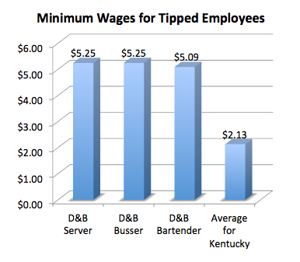

According to Glassdoor.com, Dave and Buster’s General Managers make approximately $83,545 a year and Special Events Managers make approximately $47,918 a year. Indeed.com lists the average restaurant general manager in Kentucky’s salary to be $39,000 a year. Employees will want to stay with Dave and Buster’s since it offers the best salaries in their area in their line of work.

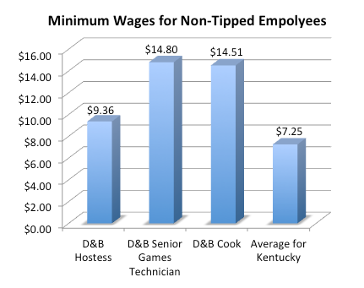

**Section 3: Tracking Responsibilities**

To make sure these expectations are met, the company will have monthly 360-degree evaluations. The managers will evaluate the employees that they oversee on their job performance. These same employees will in turn evaluate their manager. Customers will also be able to make their own evaluations. Customers will be provided a link on their receipt where they can fill out a survey on how well they perceived employees were doing their jobs. Lastly, employees will fill out a self-evaluation.

These evaluations will help keep our retention high. Employees and customers will be able to anonymously give their opinion. This will allow Dave and Buster’s to make changes to keep employees satisfied with their jobs and working hard.

**Section 4: Employee Benefits**

Dave and Buster’s employees will be provided benefits that will motivate them to stay with their job. According to Dave and Buster’s website and glassdoor.com, these include:

* Comprehensive healthcare coverage
  + Includes dental and vision plans for all full-time employees.
* 401(k) plans
* Paid time off
* Holiday pay
* Employee Discounts
  + Includes 50 percent off food.

**Section 5: Retaining Budget**

|  |  |
| --- | --- |
| **Purpose** | **Expenditure Amount** |
| General Manager Salary (1 employee) | $83,545 |
| Special Events Manager Salary (3 employees) | $143,754 |
| Server Salary (30 employees) | $302,400 |
| Busser Salary (10 employees) | $100,800 |
| Hostess Salary (10 employees) | $179,712 |
| Senior Games Technician Salary (3 employees) | $85,248 |
| Bartender Salary (5 employees) | $48,864 |
| Cook Salary (20 employees) | $557,184 |
| Healthcare | $208,000 |
| 401(k) | $24,600 |
| Paid Time-off | $49,200 |
| Holiday Pay | $32,800 |
| **Total** | $1,816,107 |

**Final HR Budget**

|  |  |
| --- | --- |
| **Purpose** | **Expenditure Amount** |
| Simply Hired Ads (three ads) | $300 |
| Free food for trainers | $96 |
| Uniforms for trainees | $120 |
| Miscellaneous training expenses | $84 |
| General Manager Salary (1 employee) | $83,545 |
| Special Events Manager Salary (3 employees) | $143,754 |
| Server Salary (30 employees) | $302,400 |
| Busser Salary (10 employees) | $100,800 |
| Hostess Salary (10 employees) | $179,712 |
| Senior Games Technician Salary (3 employees) | $85,248 |
| Bartender Salary (5 employees) | $48,864 |
| Cook Salary (20 employees) | $557,184 |
| Healthcare | $208,000 |
| 401(k) | $24,600 |
| Paid Time-off | $49,200 |
| Holiday Pay | $32,800 |
| **Total** | $1,816,707 |

**Conclusion**

Louisville is missing out on a market opportunity that the unique company, Dave and Buster’s, will help fill. Dave and Buster’s Human Resources division has done extensive research to create a plan to efficiently recruit, train, and retain employees.

Dave and Buster’s will target employees who are the best in the hospitality industry through online job ads, social media, and blogging. Louisville has a young adult population which is exactly the age group this company usually employs. Dave and Buster’s employees will be reliable, hardworking, and complete their jobs to the best of their abilities.

To accomplish this, the training program for all new employees will be broken down into three to four day segments. Each employee will be taught their specific job responsibilities as well as the Dave and Buster’s culture. At the end of training, Dave and Buster’s employees will have the abilities to accomplish their duties at the highest level.

The employees must be able to communicate well with one another, maintain professionalism at all times, and display the fun attitude that Dave and Buster’s is known for. Since Dave and Buster’s employees are held to such high standards, they will receive generous benefits to compensate for their hard work. These benefits will include comprehensive healthcare coverage, paid time off, holiday pay, and discounts. Dave and Buster’s employees will also be compensated far better than their competitors in the Louisville area. All of these factors will help keep the turnover rate low, which will help the company to reduce expenses.

Bringing Dave and Buster’s to Louisville will create a place where guests can eat, play games, and host events. Investors can potentially earn a large profit from a company that will be the first of its kind in not only Louisville, but the state of Kentucky. The Human Resources Team strongly encourages that Metro Council bring Dave and Buster’s to the city of Louisville.

**Works Cited**

"9 Simple Steps to Writing a Compelling Job Advertisement." RecruitLoop Blog. RecruitLoop, 30 Mar. 2016. Web. 04 Apr. 2016.

Carabelli, Carl. "Characteristics of Restaurant Employees." Characteristics of Restaurant Employees. Hearst Newspapers, LLC, n.d. Web. 04 Apr. 2016.

Chipotle (ChipotleTweets). "#Chipotle is hosting a job fair in #Chambersburg, PA. Get the details here" 20 Feb. Tweet.

Chipotle (ChipotleTweets). "Wanna hear us talk some serious trash? Check out our packing sustainability efforts:" 29 Mar. Tweet.

"Dave & Buster's Careers - Join the Team." Dave & Buster's Careers - Join the Team. N.p., 23 Mar. 2016. Web. 04 Apr. 2016.

"DAVE & BUSTER’S IS A PROUD PARTNER OF MAKE-A-WISH®." Dave and Busters. Dave & Buster's, n.d. Web. 4 Apr. 2016.

"Dave & Buster's Salaries." Glassdoor. N.p., n.d. Web. 04 Apr. 2016.

"Dave & Buster's Benefits." Glassdoor. N.p., n.d. Web. 04 Apr. 2016.

"Economic Development: Colleges & Universities." Greater Louisville. Greater Louisville Inc., 2014. Web. 04 Apr. 2016.

"Effective Restaurant Hiring Techniques." FSR Magazine. N.p., n.d. Web. 04 Apr. 2016.

"Highest College Student Population." U-Pack. U-Pack Moving, n.d. Web. 4 Apr. 2016.

"Kentucky Laws for Tipped Employees | Nolo.com." Nolo.com. N.p., n.d. Web. 04 Apr. 2016.

Kokemuller, Neil. "What Makes a Good Restaurant Manager?" What Makes a Good Restaurant Manager? Hearst Newspapers, LLC, n.d. Web. 04 Apr. 2016.

"Restaurant General Manager Salary in Louisville, KY." Restaurant General Manager Salary in Louisville, KY. N.p., n.d. Web. 04 Apr. 2016.

"Restaurant Workforce Demographics Are Shifting." Restaurant. National Restaurant Association, 17 Mar. 2015. Web. 04 Apr. 2016.

Shoemake, Lindsay. "Social Recruitment Strategy: Three Companies to Learn From - Chipotle." Social-Hire. Social-Hire, 03 Mar. 2013. Web. 04 Apr. 2016.

"SimplyPost Frequently Asked Questions." Simply Hired. Simply Hired, Inc., n.d. Web. 04 Apr. 2016.

Texas Roadhouse Inc. “Texas Today”. N.p.: Oct. 2015. Print.

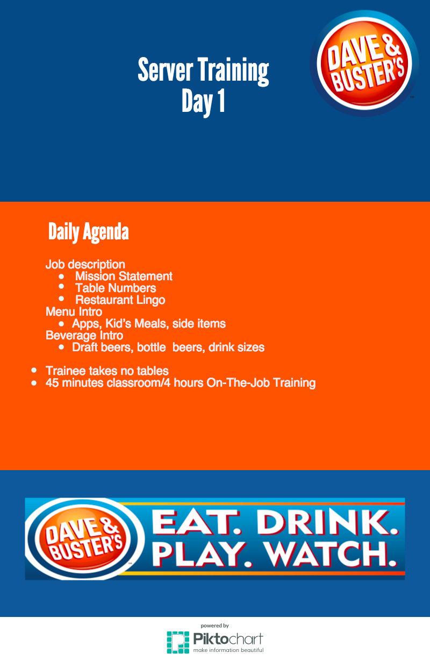

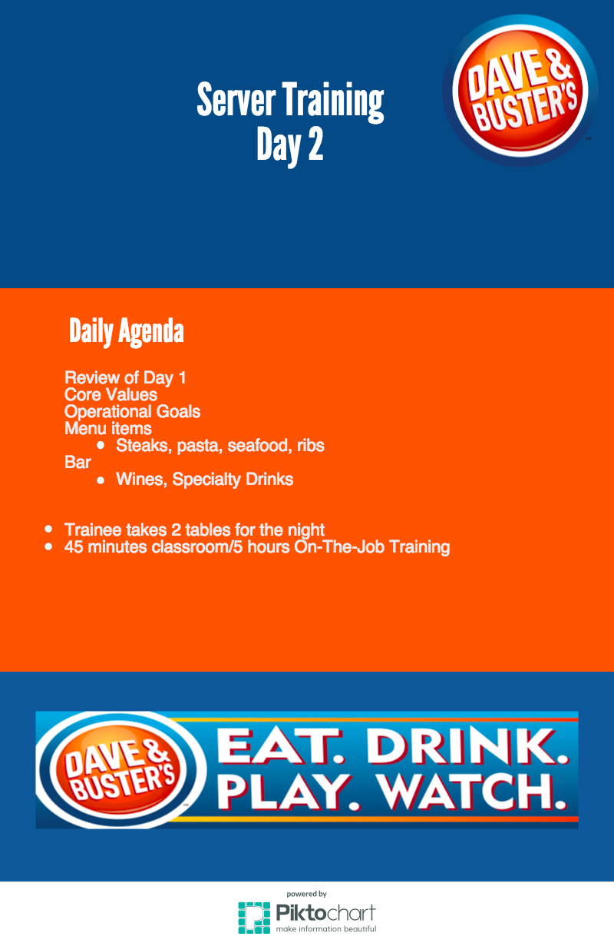

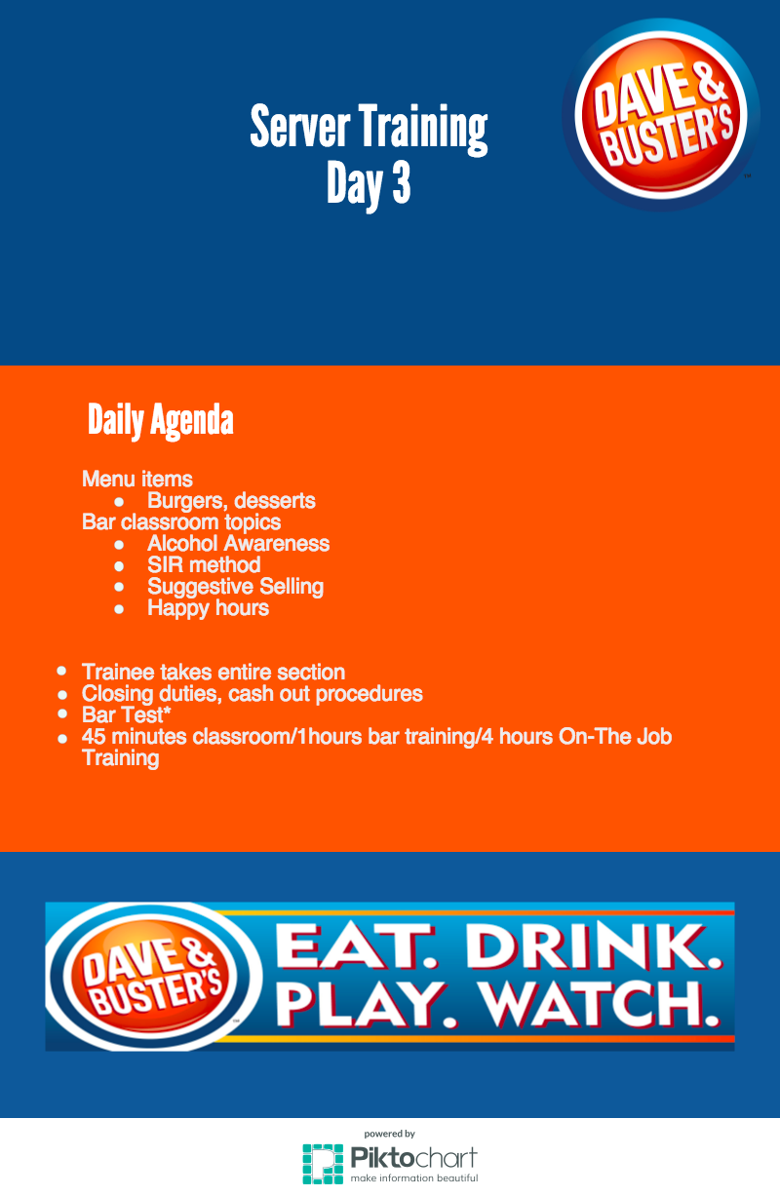

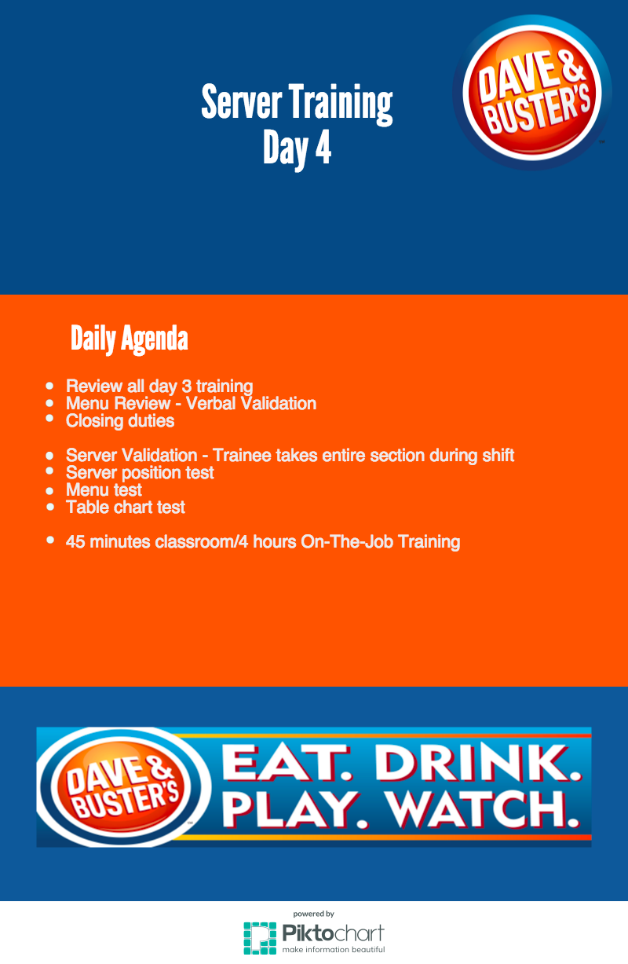

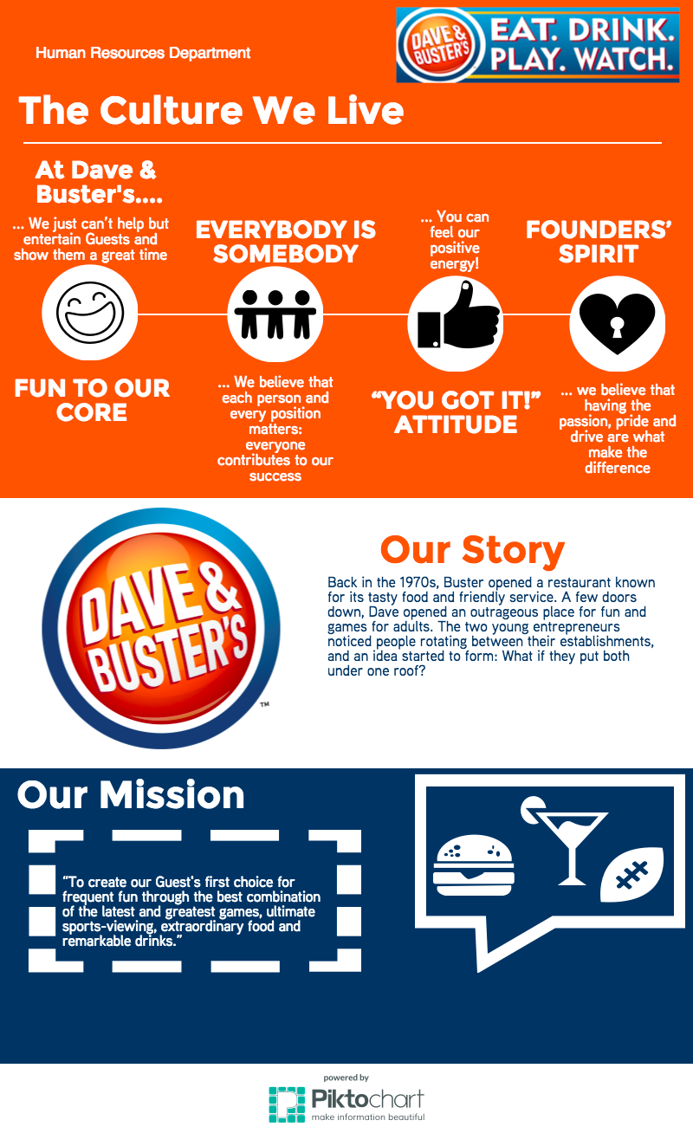The information above was taken from the Dave and Buster’s website.